Task 1

Figure 1 Mean salary of each education sorted in each year.

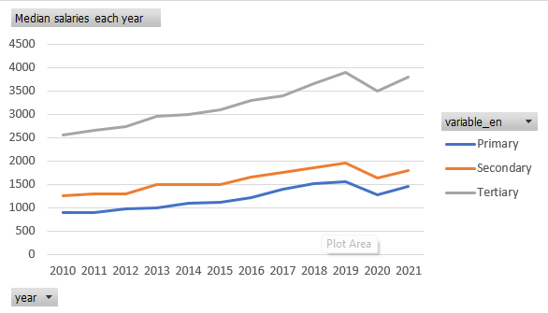

Figure 2 Median salary of each education sorted in each year.

Task 2

The two charts created in question 1 (as shown above), show that there is a significant difference between tertiary education compared to secondary and primary. This means that tertiary education has a higher salary compared to other education employees. We also can observe that every year is slightly increasing till the year 2019. And a decline in 2020 which we can assume is the year of the pandemic caused the decline in the graph where MCO is being proceeded throughout the years 2020 and the year 2021 our country slowly recovered from MCO, and we can observe it from the graph above. Besides that, the graph of mean salaries has a higher value compared to the median salaries graph. We can know that it will have some people getting higher salaries than most people which affects the mean graph be higher than the median graph.

Task 3

Based on the graph Figure 2 above we can see that there is a decrease in 2019 to 2020. As I mentioned in Task 2 the world is suffering from COVID-19 from 2019 to 2020 and our country is executing MCO throughout the year 2020 this apparently causes people to lose jobs or reduced salaries as companies need to cut costs for no working period throughout the MCO. So, the year after 2019 decreased in the graph.

Task 4

% change income for Primary education

|  |  |  |
| --- | --- | --- |
|  | % change mean | % change median |
| 2011 | 2.52572498 | 1.123595506 |
| 2012 | 3.74087591 | 8.888888889 |
| 2013 | 5.98065084 | 2.040816327 |
| 2014 | 10.1244813 | 10 |
| 2015 | 4.06932931 | 0.909090909 |
| 2016 | 5.06879073 | 8.648648649 |
| 2017 | 13.6457615 | 16.08623549 |
| 2018 | 10.430564 | 8.428571429 |
| 2019 | 5.93080725 | 2.766798419 |
| 2020 | -19.336444 | -18.3333333 |
| 2021 | 1.79305913 | 13.6577708 |

% change income for Secondary education

|  |  |  |
| --- | --- | --- |
|  | % change mean | % change median |
| 2011 | 1.75675676 | 3.2 |
| 2012 | 3.7184595 | 0.775193798 |
| 2013 | 7.55441741 | 14.69230769 |
| 2014 | 5.47619048 | 0.60362173 |
| 2015 | 2.53950339 | 0 |
| 2016 | 5.72372042 | 10 |
| 2017 | 6.97553358 | 6.060606061 |
| 2018 | 7.78588808 | 5.714285714 |
| 2019 | 7.08803612 | 5.675675676 |
| 2020 | -10.413153 | -16.6240409 |
| 2021 | 2.08 | 10.24539877 |

% change income for Tertiary education

|  |  |  |
| --- | --- | --- |
|  | % change mean | % change median |
| 2011 | 0.6557377 | 3.921568627 |
| 2012 | 3.8762215 | 3.509433962 |
| 2013 | 4.45280652 | 7.364199781 |
| 2014 | 8.64605224 | 1.867572156 |
| 2015 | 3.5092567 | 3 |
| 2016 | 6.78056594 | 6.796116505 |
| 2017 | 8 | 3.03030303 |
| 2018 | 5.39351852 | 7.294117647 |
| 2019 | 1.97671865 | 6.935307018 |
| 2020 | -10.165841 | -10.30505 |
| 2021 | 1.62550947 | 8.43098028 |

Task 5

To determine whether the inequality of income decreases or increases we can observe by checking the difference in percentage change of the median and mean for each educational level. We take the percentage of change in mean income and deduct the percentage of change in median income if it is positive then it means an increase in income inequality and if it is negative then it is a decrease in income inequality. From the table from task 4, we can see that in 2014 and 2015 for all education it increases in income inequality, and in 2016 and 2021 it decreases.

Task 6

Having a view from task 5 we know that 2014 and 2015 have increased income inequality. Based on this scenario we can assume that the lower-income stay in the low-income zone or even lower their income and the high-incomer could get higher as this would make the income inequality increase. We can also assume that lower and higher incomers increased in their income, but the higher incomer increased more than the low-income people.

But, based on research we get that in 2014 and 2015 income inequality decreased as a graph shown below.

Fig 1. Malaysia’s Income inequality

From this graph, we can clearly see that from 2012 to 2014 decreased a lot which contradicted our results from task 4,5. A report from the Ministry of Economy, states that there is an increase in income for Malaysian from 2012 to 2014. Furthermore, the Gini coefficient declined by 3 percent from 2012 to 2014. And all this research made a conclusion that the data set given might not be accurate enough to conclude anything and the only thing that might be true is both the low-income people and high-income people had increased in their income.

Reference:

Ida. L, 2020 July 10, Income inequality in Malaysia widened even while median household income rose to RM5,873 in 2019, according to the latest statistics; malaymail: <https://www.malaymail.com/news/malaysia/2020/07/10/income-inequality-in-malaysia-widened-even-while-median-household-income-ro/1883232>

MOE Department of Statistic Malaysia, 2015 July 22, Statistics on Household Income & Basic Amenities: <https://www.dosm.gov.my/portal-main/release-content/report-of-household-income-and-basic-amenities-survey-2014-#:~:text=Gini%20coefficient%20declined%20by%203.0,in%20urban%20and%20rural%20strata>.